Mewantha Manujaya Bandara, UoW ID: w1583056, IIT ID: 2015045

**Flow chart for the program:**

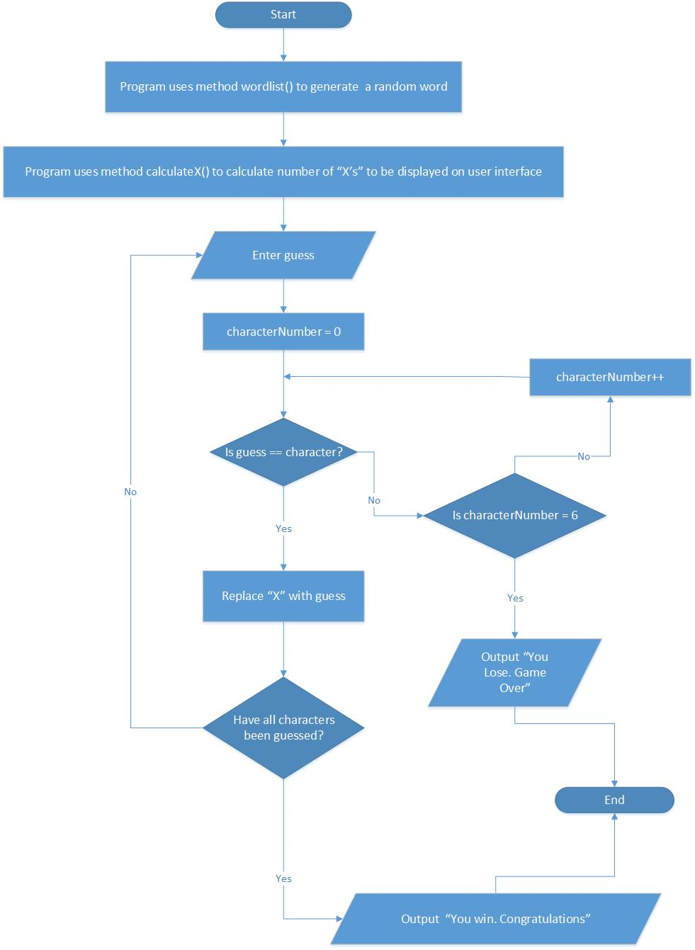

**User Interface**

Initial interface:

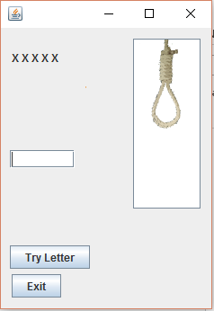

When correct letter has been input:

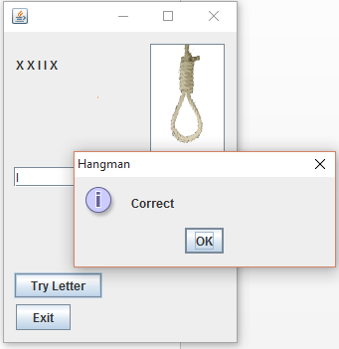

When wrong letter has been input

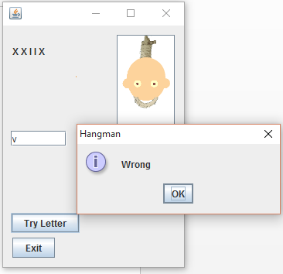

When number of tries have exceeded the allocated amount:

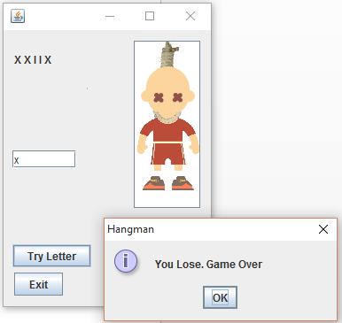

When game has been won:

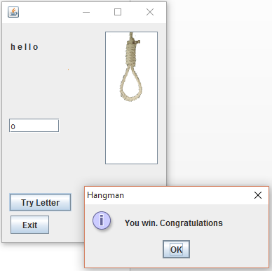

**Main program body:**

**private** **void** btnTryActionPerformed(java.awt.event.ActionEvent evt) {

body(); //Calls main body method

}

**private** **void** body(){ //Main body method

**char**[] wordArray = currentWord;

**char** wordGuess;

StringBuilder guess = **new** StringBuilder(wordHolder.getText());

wordGuess = entryField.getText().charAt(0);

wordGuess = Character.toLowerCase(wordGuess);

**boolean** flag = **false**;

**int** index = 0;

**int** indexc = 0;

**boolean** flag2 = **false**;

**while** (index < (wordArray.length)) {

**if** (wordGuess == (wordArray[index])) {

flag = **true**;

indexc = index;

guess.setCharAt(2 * index, wordGuess);

String stringguess = guess.toString();

wordHolder.setText(stringguess);

} **else** {

flag = **false**;

}

index++;

**if** (flag == **true**) {

flag2 = **true**;

}

}

**if** (flag2 == **true**) {

JOptionPane.showMessageDialog(**null**, "Correct", "Hangman", JOptionPane.INFORMATION_MESSAGE);

numberCorrect++;

**if** (numberCorrect == wordArray.length) {

JOptionPane.showMessageDialog(**null**, "You win. Congratulations", "Hangman", JOptionPane.INFORMATION_MESSAGE);

System.exit(0);

}

} **else** {

JOptionPane.showMessageDialog(**null**, "Wrong", "Hangman", JOptionPane.INFORMATION_MESSAGE);

numberOfTries++;

**if** (numberOfTries == 1) {

hangStatus.setIcon(**new** javax.swing.ImageIcon(getClass().getResource("/coursework/h1.png")));

} **else** **if** (numberOfTries == 2) {

hangStatus.setIcon(**new** javax.swing.ImageIcon(getClass().getResource("/coursework/h2.png")));

} **else** **if** (numberOfTries == 3) {

hangStatus.setIcon(**new** javax.swing.ImageIcon(getClass().getResource("/coursework/h3.png")));

} **else** **if** (numberOfTries == 4) {

hangStatus.setIcon(**new** javax.swing.ImageIcon(getClass().getResource("/coursework/h4.png")));

} **else** **if** (numberOfTries == 5) {

hangStatus.setIcon(**new** javax.swing.ImageIcon(getClass().getResource("/coursework/h5.png")));

} **else** **if** (numberOfTries == 6) {

hangStatus.setIcon(**new** javax.swing.ImageIcon(getClass().getResource("/coursework/h6.png")));

JOptionPane.showMessageDialog(**null**, "You Lose. Game Over", "Hangman", JOptionPane.INFORMATION_MESSAGE);

System.exit(0);

}

}

}

**Variables used in user interface :**

**private** javax.swing.JButton btnExit; //Exit button **private** javax.swing.JButton btnTry; //Try Letter button **private** javax.swing.JTextField entryField; //Enter guess

**private** javax.swing.JButton hangStatus; //Number of tries

**private** javax.swing.JLabel wordHolder; //Holds the X’s

**Variables declared in main class :**

**public** **char**[] currentWord; //Array to hold word to be guessed

**public** **int** numberOfTries; //Times wrong answer entered

**public** **int** numberCorrect; //Times correct answer entered

**Code extras: Write 6 different hidden words into your program and make it chose a random word each time.**

**public** Hangman() {

initComponents();

Random ran = **new** Random();

**int** num = ran.nextInt(7 - 1) + 1;

currentWord = wordlist(num); //Choose random word

**int** arrLength = currentWord.length;

calculateX(arrLength);

}

**public** **final** **char**[] wordlist(**int** num) {//List with words

**char**[] v = {'h', 'e', 'l', 'l', 'o'};

**char**[] w = {'t', 'r', 'a', 'm', 'p', 'o', 'l', 'i', 'n', 'e'};

**char**[] z = {'d', 'e', 's', 'i', 'g', 'n'};

**char**[] x = {'h', 'i', 's', 't', 'o', 'r', 'y'};

**char**[] c = {'f', 'o', 'r', 'm'};

**char**[] b = {'c', 'e', 'n', 't', 'i', 'p', 'e', 'd', 'e'};

**char**[] arr = **null**;

**switch** (num) {

**case** 1:

arr = v;

**break**;

**case** 2:

arr = w;

**break**;

**case** 3:

arr = z;

**break**;

**case** 4:

arr = x;

**break**;

**case** 5:

arr = c;

**case** 6:

arr = b;

}

**return** arr;

}

**Code extras: Make the program work for any length hidden word from 3 to 10 characters, and only display sufficient ‘X’s to match the length of the hidden word.**

**public** Hangman() {

initComponents();

Random ran = **new** Random();

**int** num = ran.nextInt(7 - 1) + 1;

currentWord = wordlist(1);

**int** arrLength = currentWord.length;

calculateX(arrLength); //Calls method to calculate X’s

}

**private** **void** calculateX(**int** length) {

**switch** (length) {

**case** 3:

wordHolder.setText("X X X");

**break**;

**case** 4:

wordHolder.setText("X X X X");

**break**;

**case** 5:

wordHolder.setText("X X X X X");

**break**;

**case** 6:

wordHolder.setText("X X X X X X");

**break**;

**case** 7:

wordHolder.setText("X X X X X X X");

**break**;

**case** 8:

wordHolder.setText("X X X X X X X X");

**break**;

**case** 9:

wordHolder.setText("X X X X X X X X X");

**break**;

**case** 10:

wordHolder.setText("X X X X X X X X X X");

**break**;

}

}

**Code extras: Work out a way to make the program display an appropriate ‘Game Over’ message.**

**if** (flag2 == **true**) {

JOptionPane.showMessageDialog(**null**, "Correct", "Hangman", JOptionPane.INFORMATION_MESSAGE);

numberCorrect++;

**if** (numberCorrect == wordArray.length) {

JOptionPane.showMessageDialog(**null**, "You win. Congratulations", "Hangman", JOptionPane.INFORMATION_MESSAGE);

System.exit(0); //If game is won

}

} **else** {

JOptionPane.showMessageDialog(**null**, "Wrong", "Hangman", JOptionPane.INFORMATION_MESSAGE);

numberOfTries++;

**if** (numberOfTries == 1) {

hangStatus.setIcon(**new** javax.swing.ImageIcon(getClass().getResource("/coursework/h1.png")));

} **else** **if** (numberOfTries == 2) {

hangStatus.setIcon(**new** javax.swing.ImageIcon(getClass().getResource("/coursework/h2.png")));

} **else** **if** (numberOfTries == 3) {

hangStatus.setIcon(**new** javax.swing.ImageIcon(getClass().getResource("/coursework/h3.png")));

} **else** **if** (numberOfTries == 4) {

hangStatus.setIcon(**new** javax.swing.ImageIcon(getClass().getResource("/coursework/h4.png")));

} **else** **if** (numberOfTries == 5) {

hangStatus.setIcon(**new** javax.swing.ImageIcon(getClass().getResource("/coursework/h5.png")));

} **else** **if** (numberOfTries == 6) {

hangStatus.setIcon(**new** javax.swing.ImageIcon(getClass().getResource("/coursework/h6.png")));

JOptionPane.showMessageDialog(**null**, "You Lose. Game Over", "Hangman", JOptionPane.INFORMATION_MESSAGE);

//If game is lost

System.exit(0);

}

}